A PROJECT REPORT ON

PRIHUB - SUPPORT FOR COGNITIVE DISABILITIES
Submitted in partial fulfillment of the requirement for the award of Degree of Bachelor of Technology in Computer Science & Engineering
Submitted to:

Rajasthan Technical University, Kota (Raj.)

Submitted By:
Pranjal Khandelwal (22EARCS125)
Ketan Chowdhury (22EARCS082)
Vishakha Tomar (22EARCS185) Pelheiba Khangebam (22EARCS121)
Under the supervision of

GUIDE PROJECT COORDINATOR

Dr. Vishal Shrivastava Dr. Vishal Shrivastava
Professor Professor


Session: 2025-26

Department of Computer Science & Engineering

ARYA COLLEGE OF ENGINEERING & I.T. SP-42, RIICO INDUSTRIAL AREA, KUKAS, JAIPUR



CERTIFICATE

This is to certify that the work embodies in this Project entitled “PRIHUB - SUPPORT FOR COGNITIVE DISABILITIES” being submitted by “Pranjal Khandelwal (22EARCS125), Ketan Chowdhury (22EARCS082), Vishakha Tomar (22EARCS185) and Pelheiba Khangebam (22EARCS121)” in partial fulfillment of the requirement for the award of “Bachelor of Technology in Computer Science & Engineering” to Rajasthan Technical University, Kota (Raj.) during the academic year 2025-26 is a record of bonafide piece of work, carried out by them under our supervision and guidance in the “Department of Computer Science & Engineering”, Arya College of Engineering & Information Technology, Jaipur.

Project Guide
Dr. Vishal Shrivastava
Professor

Project-coordinator

Dr. Vishal Shrivastava

Professor

Approved by

Dr. Akhil Pandey
Head, Department of Computer Science & Engineering



CERTIFICATE OF APPROVAL

The Project Report entitled “PRIHUB - SUPPORT FOR COGNITIVE DISABILITIES” submitted by “Pranjal Khandelwal (22EARCS125), Ketan Chowdhury (22EARCS082), Vishakha Tomar (22EARCS185) and Pelheiba Khangebam (22EARCS121)” has been examined by us and is hereby approved for carrying out the project leading to the award of degree “Bachelor of Technology in Computer Science & Engineering”. By this approval the undersigned does not necessarily endorse or approve any statement made, opinion expressed or conclusion drawn therein, but approve the pursuance of project only for the above mentioned purpose.

Project Guide Project-coordinator

Dr. Vishal Shrivastava Dr. Vishal Shrivastava
Professor Professor



DECLARATION

We “Pranjal Khandelwal, Ketan Chowdhury, Vishakha Tomar and Pelheiba Khangebam”, students of Bachelor of Technology in Computer Science & Engineering, session 2025-26, Arya College of Engineering & Information Technology, Jaipur, here by declare that the work presented in this Project entitled “PRIHUB - SUPPORT FOR COGNITIVE DISABILITIES” is the outcome of our own work, is bonafide and correct to the best of our knowledge and this work has been carried out taking care of Engineering Ethics. The work presented does not infringe any patented work and has not been submitted to any other University or anywhere else for the award of any degree or any professional diploma.

Pranjal Khandelwal (22EARCS125)
Ketan Chowdhury (22EARCS082)
Vishakha Tomar (22EARCS185)
Pelheiba Khangebam (22EARCS121)

Date: 03.02.2026

ACKNOWLEDGEMENT

I would like to express my sincere gratitude to Dr. Vishal Shrivastava, Project Guide, for being a motivating and tremendous guide throughout the journey of the project titled “PRIHUB – SUPPORT FPOR COGNITIVE DISABILITIES” His constant motivation, valuable guidance, and continuous support helped me to successfully complete this project.
Also, I would like to pay my regards to all the faculties and trainers, who have been a great help to me throughout this journey, encouraging me and helping me to complete the project successfully.
I would like to thank Dr. Akhil Panday, Head of the Department of Computer Science, for his meticulous supervision to carry out the work perfectly and in a disciplined manner. I acknowledge with thanks my friends who have been constant pillars and have helped me in completing the project at the specified time. I am highly grateful to Arya College of Engineering and I.T., without whom this project would not have been possible.

Pranjal Khandelwal (22EARCS125)
Ketan Chowdhury (22EARCS082)
Vishakha Tomar (22EARCS185)
Pelheiba Khangebam (22EARCS121)

ABSTRACT

PRIHUB is a full-stack, accessibility-focused web platform developed to support individuals with cognitive and visual disabilities by providing an inclusive and user-friendly digital environment. Many existing online platforms lack essential accessibility features, which restrict independent usage and meaningful engagement for users with special needs. PRIHUB addresses these challenges through an accessibility-first design integrated with intelligent assistive technologies.
The platform is developed using modern web technologies such as HTML, CSS, JavaScript, React.js, Node.js, and Firebase for secure authentication and real-time data management. Core features include screen reader compatibility, text-to-speech support, simplified and intuitive user interfaces, high-contrast display modes, keyboard navigation, and an AI-powered chatbot that offers guided navigation and real-time assistance.
Developed in accordance with Software Development Life Cycle (SDLC) principles, PRIHUB ensures scalability, maintainability, and efficient performance. By promoting digital inclusion, independence, and equal access to online resources, PRIHUB serves as a reliable digital support platform for individuals with cognitive and visual disabilities.

TABLE OF CONTENTS

Chapter. No. Name of the Chapter Page No.
1. Objective & Scope of the Project 1
2. Theoretical Background 9
3. Definition of Problem 12
4. System Analysis & User Requirements 14
5. System Planning (PERT Chart) 16
6. Methodology adopted & Details of Hardware & Software used 18
7. Detailed Life Cycle of the Project 20
8. ERD (Entity Relationship Diagram), DFD (Data Flow Diagram) 23
9. Process involved, Algorithm, Flowchart & Database diagram 25
10. Input and Output Screen Design (Screen Shots) 30
11. Printout of the Code Sheet (Coding) 37
12. Testing 44
13. User/Operational Manual 47
14. Conclusions 50
15. Future enhancement 51
16. List of publications 52
17. Reference 53
CHAPTER – 1.
OBJECTIVE & SCOPE OF THE PROJECT
  - Objective
The objective defines the purpose, goals, and intended outcomes of the PRIHUB project. It sets the foundation for why the project exists and what problems it aims to solve.
The project title is:
“PRIHUB – Support for Cognitive Disabilities”
The platform is designed as a full-stack web application with the following key characteristics:
- Accessibility-first: Prioritizes users with cognitive and visual disabilities.
- Inclusive: Ensures the platform is usable by people with varying abilities.
- User-centric: Designed around the needs, preferences, and abilities of the end-users.

Why PRIHUB is Needed
- Current Digital Landscape
  - Most web platforms are designed for the general population.
  - They assume normal cognitive and visual abilities, often ignoring users with disabilities.
- Challenges Faced by Individuals with Disabilities
  - Cognitive impairments like autism, ADHD, dementia, or learning disabilities make navigation, comprehension, and task execution difficult.
  - Visual impairments make traditional text-heavy or poorly contrasted interfaces inaccessible.
  - Users often feel excluded, frustrated, and dependent on others to use digital platforms.
- Gap PRIHUB Fills
  - Provides a single platform integrating accessibility, assistive technologies, and AI guidance.
  - Enables users to consume digital content independently, reducing dependency on caregivers.
  - Encourages confidence, engagement, and inclusion in digital activities.

Specific Objectives of PRIHUB
- Eliminate Accessibility Barriers
- Many websites and applications are not designed for cognitive or visual impairments, resulting in usability challenges.
- PRIHUB applies accessibility-first design principles, including:
  - Semantic HTML
  - ARIA roles for assistive technologies
  - Simplified navigation
  - Consistent layouts
- Outcome: Users can interact with the platform without frustration or external help.
- Provide Assistive Technologies
  - Text-to-Speech (TTS): Reads text aloud, allowing visually impaired users or those with reading difficulties to consume content.
  - Optical Character Recognition (OCR): Converts printed or scanned documents into readable text for the platform.
  - Screen-reader compatibility: Makes all content navigable and readable by screen readers.
- Impact: Users can access digital resources independently, improving usability and inclusivity.
- Integrate AI-powered Chatbot
  - The chatbot provides real-time conversational assistance, including:
  - Navigation guidance: Helps users find pages or complete tasks.
  - Query resolution: Answers common questions in natural language.
  - Contextual support: Offers assistance tailored to the user’s current activity.
- Benefit: Reduces cognitive load, frustration, and dependency, allowing a guided, yet independent, experience.
- Promote Independence and Engagement
- By combining assistive technologies and AI guidance, PRIHUB empowers users to:
  - Perform digital tasks on their own
  - Engage with online content meaningfully
  - Build confidence in using technology
- Outcome: Users feel self-reliant, which is particularly important for people with cognitive or visual disabilities.
- Structured Development Using SDLC
- PRIHUB is developed following the Software Development Life Cycle (SDLC) to ensure:
  - Quality: Error-free, user-friendly, and reliable system
  - Scalability: Can handle growing numbers of users and institutions
  - Maintainability: Easy to update or extend features
  - Reliability: Stable and consistent performance
- Impact: Users and institutions can trust the platform for long-term usage.
- Promote Awareness and Social Good
- Beyond technical functionality, PRIHUB serves as a socially responsible project:
  - Demonstrates the importance of inclusive design
  - Encourages other developers and organizations to adopt universal accessibility standards
  - Shows how modern web technologies can create positive social impact

1.2 Scope of the Project — Detailed Explanation
The scope defines what the PRIHUB project will cover, both technically and functionally, as well as its intended audience and market reach. It sets boundaries for what the system will achieve, how it will be built, and who will benefit from it.
The project aims to develop a secure, scalable, and accessibility-first full-stack web platform that serves individuals with cognitive and visual disabilities, while also allowing institutional adoption.

1.2.1 Scope for Primary Users (Individuals with Cognitive & Visual Disabilities)
This defines how PRIHUB supports end users with disabilities:
- Accessible Content Consumption
  - Users with visual or cognitive disabilities often struggle to access standard digital content.
  - PRIHUB uses Text-to-Speech (TTS) to read content aloud, screen readers to interpret text for visually impaired users, and simplified layouts to reduce cognitive load.
  - This allows users to independently consume information.
- Guided Navigation
  - Cognitive disabilities can make navigation on traditional websites confusing.
  - An AI-powered chatbot guides the user step by step, answering queries, providing instructions, and helping them reach their goal without frustration.
- Task & Reminder Assistance
  - Users can set reminders, maintain notes, and manage daily schedules.
  - This helps people with memory-related impairments (e.g., ADHD, dementia) stay organized and independent.
- Personalized Accessibility Settings
  - Users can adjust font sizes, contrast themes, color schemes, and other interaction preferences.
  - Personalization ensures comfort and usability for different levels of cognitive or visual abilities.
- Independent Digital Interaction
  - The ultimate goal is digital independence, reducing reliance on caregivers or family members for everyday digital tasks like reading notices, accessing educational content, or using online tools.

1.2.2 Scope for Caregivers & Support Personnel
PRIHUB recognizes that some users still need supervised assistance:
- Caregivers can help set up accessibility preferences based on the user’s abilities.
- They can assist with managing reminders and notes while ensuring the user remains in control.
- The platform allows caregivers to monitor usage in a secure, controlled way, protecting privacy while still providing guidance.
- Purpose: Ensures support without overstepping independence.

1.2.3 Scope for Institutions & Organizations
PRIHUB is not just for individual users; it can also be scaled to schools, hospitals, NGOs, and government organizations:
- Educational Institutions
  - Students with learning disabilities can access inclusive learning tools, assignments, and reminders.
  - Teachers can track progress without compromising privacy.
- Healthcare Providers
  - Cognitive rehabilitation centres can provide patients with digital guidance, reminders, and task management.
  - Helps in therapeutic or rehabilitation routines.
- NGOs & Government Bodies
  - Promotes digital inclusion initiatives by providing a free or low-cost platform for accessibility.
  - Supports awareness campaigns for inclusivity.
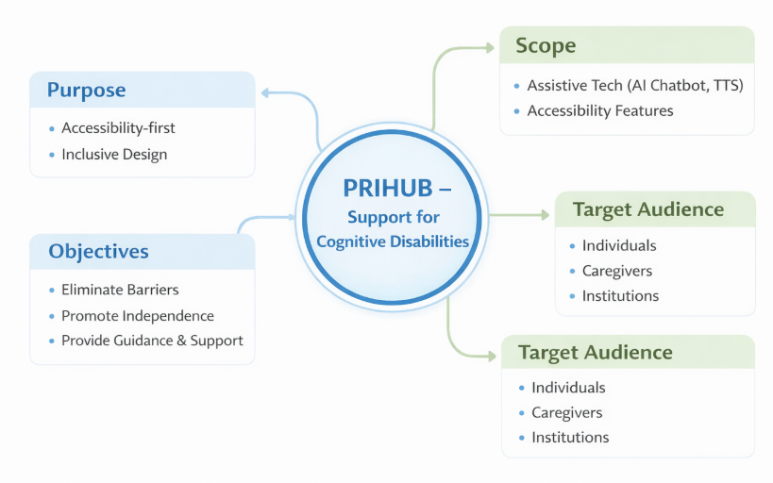
1.2.4 Technical Scope
This section describes how the system is built:
- Frontend Development
- Developed using HTML, CSS, JavaScript, React.js.
- Must be responsive (works on mobile and desktop) and accessible for screen readers.
- Supports keyboard-only navigation and includes high-contrast themes, dyslexia-friendly fonts, and adjustable font sizes.
- Backend Development
- Uses Node.js and Express.js for scalable, secure backend.
- Firebase Authentication ensures secure login and role-based access.
- Firebase Database allows real-time data storage and cloud backups.
- Accessibility & Assistive Features
- Screen-reader compatibility using semantic HTML and ARIA roles.
- TTS and keyboard navigation for people with motor impairments.
- Task and reminder assistance for cognitive support.
- Artificial Intelligence Integration
- Chatbot provides real-time navigation guidance, query resolution, and contextual assistance.
- Reduces cognitive burden and helps users interact confidently.
- Core Functional Modules
- User authentication and profile management
- Task management with reminders and notes
- Secure session handling
- Privacy and role-based access
- Development Methodology
- Follows SDLC phases:
- Planning → Requirement Analysis → System Design → Development → Testing → Deployment → Maintenance
- Purpose: Ensures a structured, reliable, and maintainable system.

1.2.5 Market Scope and Strategy
PRIHUB is designed with a social impact mindset, focusing on inclusivity and scalability:
- Target Market
- Individuals with cognitive and visual disabilities
- Schools and inclusive education centres
- Healthcare and rehabilitation organizations
- NGOs promoting disability and Government digital inclusion programs.
- Value Proposition
- Accessibility-first design
- AI-driven support for real-time guidance
- Cost-effective and scalable
- Promotes digital independence and social inclusion
- Adoption Strategy
- Pilot deployment in schools and NGOs
- Collaboration with healthcare centres
- Demonstration via academic projects and social innovation events
- Scaling through institutional partnerships
- Growth & Future Expansion
- Mobile apps (Android/iOS)
- Multilingual and regional language support
- AI-based personalization
- Integration with public and government services
- Sustainability Strategy
- Open-source or freemium model
- Institutional licensing for large deployments
- Community-driven feature enhancement
- Continuous improvement using user feedback

1.2.6 Limitations
- PRIHUB does not include commercial monetization at this stage.
- Designed to scale in future for NGOs, educational institutions, healthcare providers, or government initiatives.

CHAPTER – 2.
THEORETICAL BACKGROUND
The PRIHUB platform is founded on established theories and principles from inclusive design, human–computer interaction (HCI), accessibility engineering, assistive technologies, artificial intelligence, and software engineering methodologies. These theoretical foundations ensure that the system is not only technically robust but also empathetic, usable, and socially impactful.

2.1 Accessibility and Inclusive Design Theory
Inclusive design focuses on creating digital systems that can be accessed, understood, and used by people with diverse abilities, including those with cognitive and visual impairments. Unlike traditional design approaches that target an “average” user, inclusive design emphasizes flexibility, adaptability, and user diversity.
The Web Content Accessibility Guidelines (WCAG 2.1) define four fundamental accessibility principles:
- Perceivable: Information must be presented in ways users can perceive (e.g., text alternatives, TTS).
- Operable: Users must be able to navigate interfaces using various input methods (keyboard-only navigation).
- Understandable: Content and navigation should be clear, consistent, and predictable.
- Robust: Content must be compatible with assistive technologies.
PRIHUB applies these principles through:
- Semantic HTML for assistive technology compatibility
- ARIA roles for screen reader support
- High-contrast themes and adjustable fonts
- Simplified layouts and minimal distractions
This ensures that accessibility is embedded into the system architecture, not treated as an afterthought.

2.2 Cognitive Load Theory
Cognitive Load Theory explains how human memory and attention can be overwhelmed by poorly designed interfaces. Individuals with cognitive disabilities such as ADHD, autism, or dementia experience increased difficulty processing complex information.
PRIHUB reduces cognitive load through:
- Simplified and consistent UI layouts
- Clear labelling and predictable navigation
- Step-by-step AI chatbot guidance
- Visual and audio feedback after every action
By reducing unnecessary mental effort, the platform improves task completion, comprehension, and user confidence.
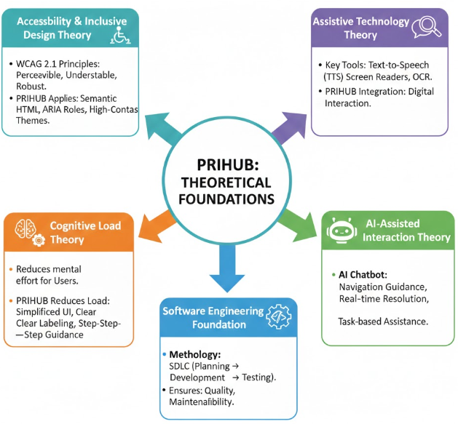
2.3 Assistive Technology Theory
Assistive technologies enable individuals with disabilities to perform tasks that would otherwise be difficult or impossible. Key assistive tools include:
- Text-to-Speech (TTS) for auditory content delivery
- Screen readers for visually impaired users
- OCR for converting printed or scanned content into readable digital text
PRIHUB integrates these technologies directly into the web platform, eliminating reliance on third-party tools and enabling independent digital interaction.

2.4 AI-Assisted Interaction Theory
Artificial Intelligence, particularly conversational AI, enables natural and intuitive interaction between users and systems. The AI chatbot in PRIHUB follows context-aware assistance theory, where responses are tailored to the user’s current activity.
Functions include:
- Navigation guidance
- Real-time problem resolution
- Task-based assistance
- Cognitive support through conversational interaction
This reduces frustration and empowers users to explore the platform independently.

2.5 Software Engineering Foundation
PRIHUB follows the Software Development Life Cycle (SDLC) to ensure:
- Structured development
- Quality assurance
- Maintainability
- Scalability
Applying SDLC principles ensures the system remains reliable, extensible, and suitable for long-term institutional adoption.

CHAPTER – 3.
DEFINITION OF THE PROBLEM
Despite rapid advancements in digital technologies and widespread digitization across education, healthcare, governance, and social platforms, individuals with cognitive and visual disabilities continue to face significant barriers in accessing and effectively using digital systems. Most modern web applications are designed with assumptions of normal cognitive functioning and visual perception, which unintentionally excludes a large section of the population with special needs.
Cognitive disabilities such as ADHD, autism spectrum disorders, learning disabilities, and dementia affect attention span, memory, comprehension, and decision-making abilities. Similarly, visual impairments limit the ability to perceive text, colours, layouts, and visual cues used extensively in standard web interfaces. When digital platforms fail to address these challenges, users experience frustration, dependency on caregivers, and reduced participation in digital activities.
The lack of inclusive digital environments not only restricts access to information and services but also negatively impacts self-confidence, independence, and social inclusion. Therefore, there is a critical need for a platform that prioritizes accessibility, usability, and cognitive support from the initial design stage.

3.1 Identified Problems
The following key issues have been identified in existing digital platforms:
- Most websites are designed assuming normal cognitive and visual abilities, ignoring the needs of users with disabilities.
- User interfaces are often cluttered, text-heavy, and visually complex, making them difficult to understand and navigate.
- There is an absence of built-in assistive technologies such as screen readers, Text-to-Speech (TTS), OCR, and keyboard-only navigation.
- Platforms lack real-time guidance or contextual assistance, which is crucial for users with cognitive impairments.
- Users remain highly dependent on caregivers or family members for performing basic digital tasks.
- Poor accessibility results in reduced engagement, shorter session durations, and digital exclusion.
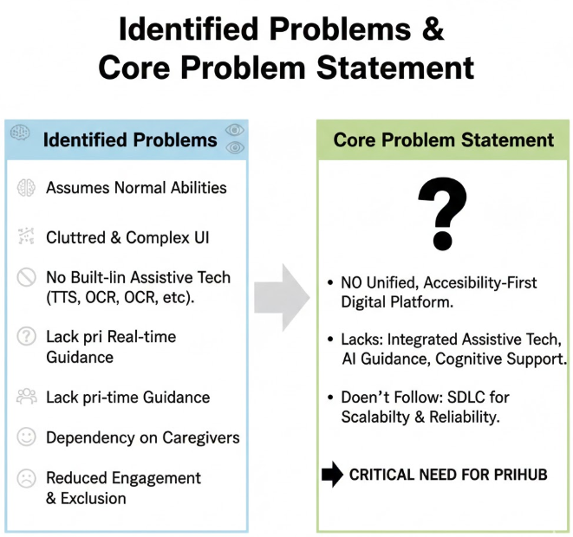
3.2 Core Problem Statement
There is no unified, accessibility-first digital platform that effectively integrates assistive technologies, AI-based guidance, and cognitive support tools while adhering to structured Software Development Life Cycle (SDLC) principles to ensure scalability, security, reliability, and long-term sustainability. This gap necessitates the development of an inclusive system like PRIHUB.
CHAPTER– 4.
SYSTEM ANALYSIS & USER REQUIREMENTS
This section analyses the existing systems, identifies their limitations, and defines the functional and non-functional requirements of the proposed PRIHUB platform.

4.1 Existing System Analysis
The analysis of existing web platforms reveals the following limitations:
- Systems are generic and not designed specifically for individuals with cognitive or visual disabilities.
- Accessibility is often treated as an optional feature rather than a core design principle.
- Cognitive accessibility aspects such as simplified language, structured layouts, and guided navigation are missing.
- Platforms do not provide adaptive or personalized assistance.
- Limited customization options fail to address individual user needs.
- As a result, these systems are unsuitable for users requiring additional support and accessibility accommodations.
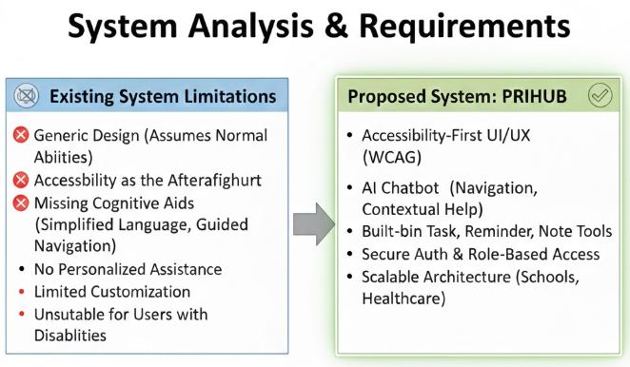
4.2 Proposed System
The proposed system, PRIHUB, addresses the limitations of existing platforms by introducing an inclusive, accessibility-first digital environment.
Key features of the proposed system include:
- Accessibility-first UI/UX design following WCAG guidelines.
- AI-powered chatbot for real-time navigation and contextual assistance.
- Built-in task, reminder, and note management tools for cognitive support.
- Secure authentication and role-based access control.
- Scalable architecture suitable for institutional adoption in schools, healthcare centres, NGOs, and government bodies.

4.3 User Requirements
4.3.1 Functional Requirements
- Secure user registration and authentication.
- Text-to-Speech and screen reader compatibility.
- AI chatbot assistance for navigation and query resolution.
- Task, reminder, and note management.
- Personalized accessibility settings (font size, contrast, themes).
- Role-based access for users, caregivers, and administrators.
4.3.2 Non-Functional Requirements
- High availability and fast response time.
- Strong data security and privacy protection.
- Scalability to support increasing users.
- Compliance with accessibility standards.
- Responsive user interface across devices.
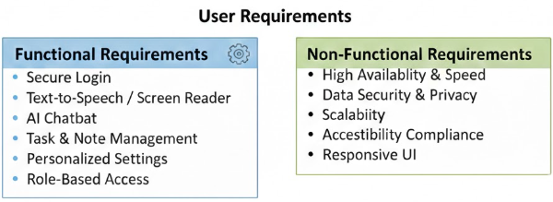
CHAPTER – 5.
SYSTEM PLANNING (PERT CHART)
System planning for the PRIHUB project is carried out using the PERT (Program Evaluation Review Technique), a well-established project management and scheduling technique widely used in software engineering. PERT helps in planning, organizing, coordinating, and monitoring project activities, especially when multiple dependent tasks are involved.
The use of a PERT chart enables the development team to break down the project into manageable activities, determine the logical sequence of tasks, estimate time durations, and identify critical paths that directly affect project completion. This structured planning approach reduces uncertainty, avoids resource conflicts, and ensures that the project progresses smoothly within the defined timeline.
By visualizing the complete development lifecycle, the PRIHUB team can monitor progress at each stage, identify potential delays early, and take corrective actions when required. This systematic planning is particularly important for accessibility-focused systems where usability, testing, and feedback cycles play a crucial role.

5.1 Major Activities Identified
The major activities involved in the PRIHUB project are as follows:
- Requirement Analysis: This phase focuses on understanding user needs, accessibility challenges faced by individuals with cognitive and visual disabilities, system expectations, and technical constraints. Feedback from potential users and caregivers is analysed to ensure inclusivity.
- System Design: In this stage, the overall system architecture is designed, including frontend structure, backend workflows, UI wireframes, database schemas, and accessibility design guidelines.
- Frontend Development: Accessible user interfaces are developed using React.js and web technologies. Special emphasis is placed on screen reader compatibility, keyboard navigation, high-contrast themes, and simplified layouts.
- Backend Development: Server-side logic, APIs, authentication mechanisms, and data handling processes are implemented using Node.js, Express.js, and Firebase.
- AI Integration: The AI-powered chatbot is integrated to provide real-time assistance, navigation guidance, and contextual support to users, reducing cognitive load.
- Testing: Comprehensive testing is conducted, including functional testing, accessibility testing, security testing, and performance evaluation.
- Deployment: The system is hosted on cloud infrastructure, ensuring scalability, availability, and secure access.
- Maintenance: Continuous monitoring, bug fixing, performance optimization, and feature enhancements are carried out after deployment.

5.2 Dependency Flow
The dependency sequence of project activities is as follows:
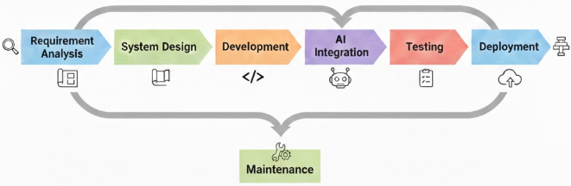
Each phase depends on the successful completion of the previous phase. The PERT chart visually represents these dependencies along with estimated time durations, helping ensure that the project progresses in a timely, organized, and structured manner.

CHAPTER – 6.
METHODOLOGY ADOPTED & DETAILS OF HARDWARE & SOFTWARE USED
6.1 Methodology Adopted
The PRIHUB project follows the Software Development Life Cycle (SDLC) using a Waterfall model with iterative feedback. This approach combines the clarity of a linear development process with the flexibility to refine features based on feedback obtained during development and testing.
Each phase of SDLC is clearly defined, ensuring systematic development, better documentation, and improved quality control. Iterative feedback allows refinements in accessibility features and user experience without disrupting the overall project flow.
SDLC Phases Applied
- Planning: Defining project objectives, scope, timeline, feasibility, and resource allocation.
- Analysis: Gathering detailed functional and non-functional requirements, especially accessibility and usability requirements.
- Design: Creating system architecture, UI wireframes, database schemas, and accessibility guidelines.
- Development: Coding frontend components, backend services, and AI chatbot logic.
- Testing: Verifying system functionality, accessibility compliance, security, and performance.
- Deployment: Making the system available to users through cloud hosting.
- Maintenance: Fixing bugs, optimizing performance, adding features, and ensuring system stability.
This methodology ensures quality, reliability, scalability, and maintainability of the PRIHUB platform.

6.2 Hardware Requirements
The minimum hardware configuration required for development and usage of PRIHUB is as follows:
- Processor: Intel i3 or higher
- RAM: Minimum 4GB (8GB recommended for smooth development and testing)
- Storage: Minimum 20GB free disk space
- Internet Connectivity: Stable broadband connection
These hardware requirements ensure efficient development, testing, cloud integration, and real-time data synchronization.

6.3 Software Requirements
The software environment used for the PRIHUB platform includes:
- Operating System: Windows, Linux, or macOS
- Frontend Technologies: HTML, CSS, JavaScript, React.js
- Backend Technologies: Node.js, Express.js
- Database & Authentication: Firebase
- Development Tools: Visual Studio Code, GitHub, Browser Developer Tools
All selected technologies are open-source, scalable, cost-effective, and industry-relevant, making the system suitable for long-term usage and institutional adoption.
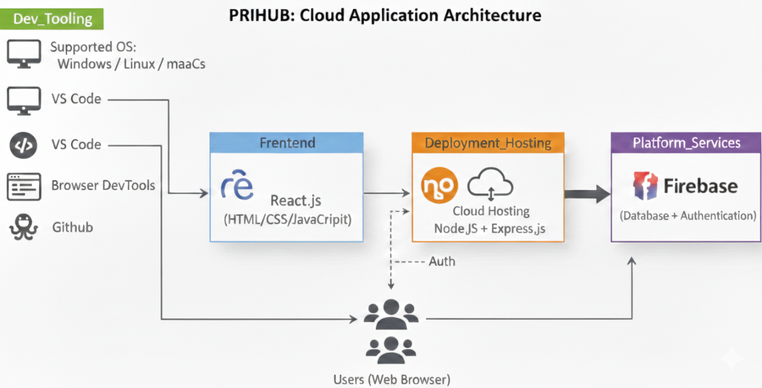
CHAPTER – 7.
DETAILED LIFE CYCLE OF THE PROJECT
The PRIHUB project follows a structured and well-defined software development life cycle to ensure that the system is reliable, scalable, accessible, and user-centric. Each phase of the life cycle contributes directly to the quality, performance, and usability of the final system.

7.1 Planning Phase
The planning phase forms the foundation of the entire project. During this stage, the overall objectives of PRIHUB are clearly defined, with a strong focus on accessibility and inclusion for users with cognitive and visual disabilities. The scope of the project is determined by identifying essential features such as assistive technologies, AI-based guidance, and secure user management.
Key activities in this phase include feasibility analysis, resource allocation, timeline estimation, and risk identification. Special consideration is given to ethical and accessibility requirements to ensure compliance with global standards.

7.2 Requirement Analysis Phase
In this phase, detailed functional and non-functional requirements are gathered. User requirements are collected by studying real-world accessibility challenges faced by individuals with cognitive and visual impairments, caregivers, and administrators.
Accessibility needs such as screen reader compatibility, simplified navigation, and cognitive load reduction are carefully analysed. System constraints, security expectations, and performance requirements are also documented. This phase ensures that the system is designed to meet real user needs rather than theoretical assumptions.

7.3 System Design Phase
The system design phase translates requirements into a structured technical blueprint. Logical and physical designs are created for both frontend and backend components.
This includes defining system architecture, selecting appropriate technologies, designing UI wireframes with inclusive design principles, and preparing database schemas. Accessibility guidelines such as WCAG compliance, semantic HTML usage, and keyboard navigation support are embedded directly into the design process.
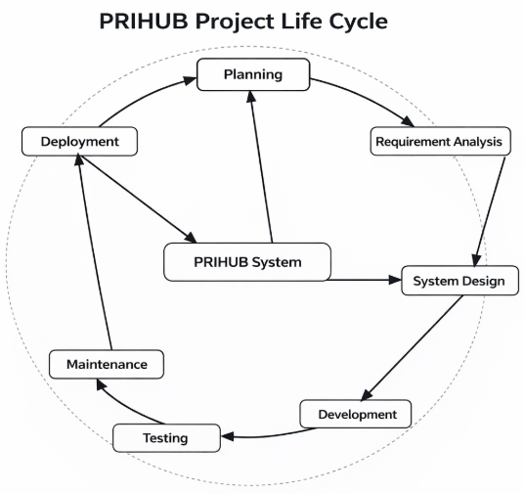
7.4 Development Phase
During development, the system design is converted into a working application. Frontend interfaces are developed using React.js with a focus on clean layouts, readable typography, and assistive interaction patterns.
The backend is implemented using Node.js and Express.js, handling authentication, data management, and API communication. The AI chatbot is integrated to provide real-time, context-aware assistance using natural language interaction, reducing user dependency on manual navigation.

7.5 Testing Phase
Testing is a critical phase to ensure system correctness, security, and accessibility. Multiple testing techniques are applied, including unit testing for individual components, integration testing for module interaction, accessibility testing based on WCAG guidelines, and security testing for data protection.
User acceptance testing is conducted to gather feedback from real users and caregivers, ensuring that the system meets usability and accessibility expectations.

7.6 Deployment Phase
Once testing is completed, the system is deployed on cloud infrastructure. Deployment includes server configuration, database setup, and security configurations. The system is made available to users through a web interface, ensuring high availability and reliability.

7.7 Maintenance Phase
The maintenance phase focuses on long-term system stability and improvement. Regular updates, bug fixes, performance optimization, and feature enhancements are carried out. User feedback is continuously analysed to improve accessibility, usability, and functionality.

CHAPTER – 8.
ERD & DFD
8.1 Entity Relationship Diagram (ERD)
The Entity Relationship Diagram represents the logical structure of the PRIHUB database and defines how data entities are related to each other.
Entities Description
- User: Stores user profiles, preferences, and authentication data.
- Caregiver: Represents individuals who assist users and monitor tasks or reminders.
- Task: Stores information related to daily activities, goals, and schedules.
- Reminder: Manages notifications and alerts for tasks and important events.
- Chatbot Interaction: Logs user-AI conversations for improving assistance quality.
- Settings: Stores personalized accessibility and interface preferences.
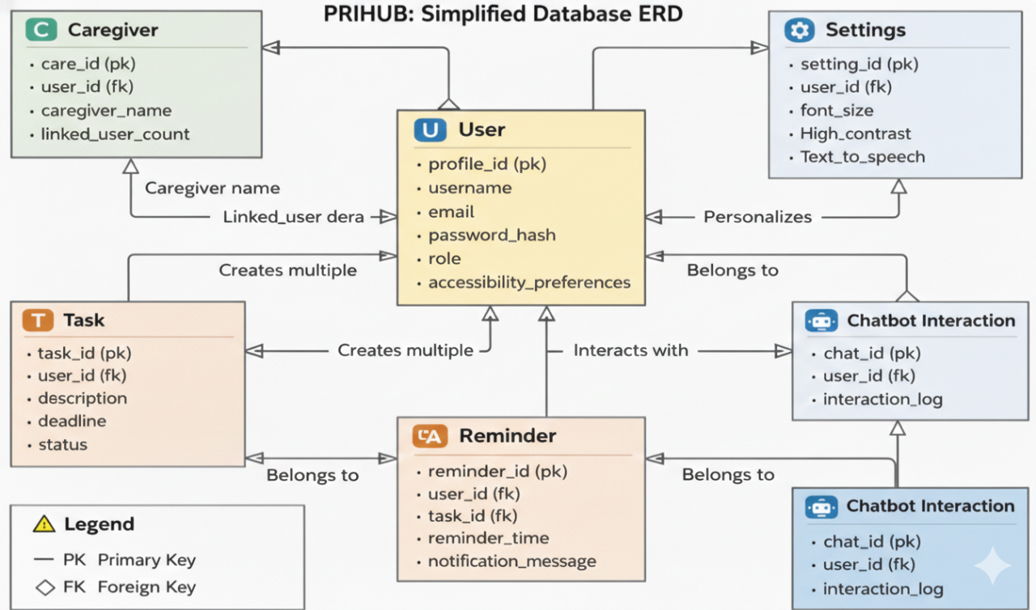
Relationships
- A User can create multiple Tasks, indicating a one-to-many relationship.
- A User can set multiple Reminders for different activities.
- A User interacts with the Chatbot, generating multiple interaction records.
- A Caregiver can assist one or more Users, supporting dependent users.
This design ensures data consistency, minimal redundancy, scalability, and efficient data retrieval.

8.2 Data Flow Diagram (DFD)
Level 0 DFD
The Level 0 DFD provides a high-level overview of the system:
“User → PRIHUB System → Firebase Database”
This shows how user input flows into the system and how data is stored securely.
Level 1 DFD
The Level 1 DFD provides a detailed breakdown of internal processes:
- Authentication: Handles secure login and role-based access.
- Task Management: Manages creation, updates, and deletion of tasks.
- Chatbot Interaction: Processes user queries and generates AI responses.
- Accessibility Settings: Stores and applies user-specific accessibility preferences.
These processes demonstrate controlled and secure data movement within the system.
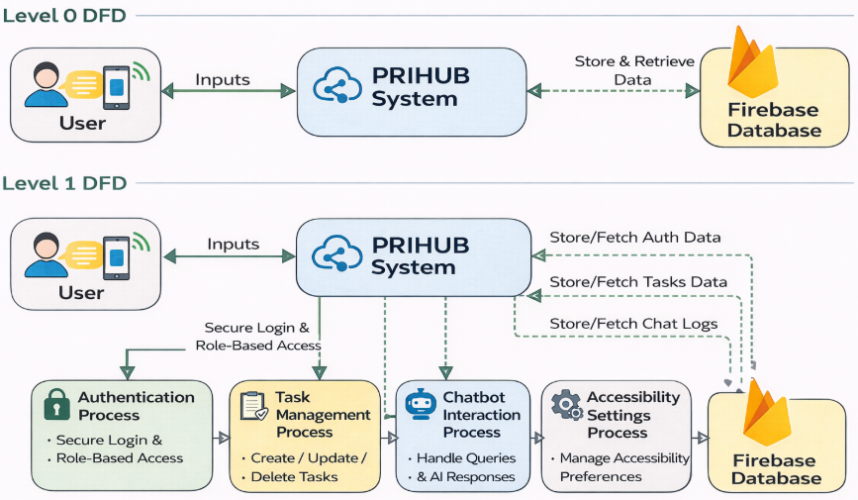
CHAPTER – 9.
PROCESS INVOLVED, ALGORITHM, FLOWCHART & DATABASE DIAGRAM
9.1 Process Involved
The PRIHUB system operates through a well-defined, user-centric workflow designed specifically to support individuals with cognitive and visual disabilities. The system emphasizes accessibility, security, and simplicity, ensuring that users can interact with digital services independently and confidently.

Overall System Process
1. User Registration and Authentication: The system begins with secure user registration and login using Firebase Authentication. Each user is assigned a role based on their profile:
- User – individuals with cognitive or visual disabilities
- Caregiver – family members or support staff who assist users
- Admin – system administrators responsible for platform management
This role-based authentication ensures controlled access to system features and protects sensitive user data.

2. Accessibility Preference Setup: Once authenticated, users or caregivers configure personalized accessibility settings to meet individual needs. These settings include:
- Adjustable font size for improved readability
- High-contrast colour themes for visual clarity
- Text-to-Speech (TTS) support for audio assistance
- Keyboard navigation for users with limited motor control
These preferences are stored and automatically applied every time the user logs in, creating a consistent and inclusive experience.

3. System Interaction: Users interact with PRIHUB through a highly accessible interface that minimizes cognitive overload. The system provides:
- Simple navigation with clear icons and labels
- AI-powered chatbot support
- Task management and reminder modules
All interactions are designed to be intuitive and predictable.
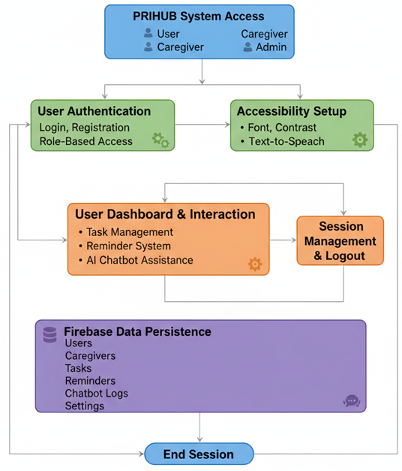
- AI Chatbot Assistance
The AI chatbot acts as a virtual assistant, offering:
- Step-by-step navigation guidance
- Contextual help for system features
- Natural language responses tailored to user queries
This reduces user confusion, supports independent usage, and enhances overall engagement.
- Data Storage and Management
All system data is securely stored in the Firebase Database. Key features include:
- Real-time data synchronization
- Automatic backups
- Secure access controls
This ensures data reliability, consistency, and protection across all user sessions.

- Session Management and Logout
The system implements secure session handling to prevent unauthorized access. Users can safely log out at any time, ensuring privacy and compliance with data protection standards.

9.2 Algorithm
Algorithm: User Interaction with PRIHUB System
- Start
- Display Login / Registration Page
- Accept user credentials
- Validate credentials using Firebase Authentication
- If authentication fails:
- Display error message
- Redirect to login page
- If authentication succeeds:
  - Load user dashboard based on role
- Retrieve and apply saved accessibility preferences
- Display accessible user interface
- Wait for user action
- If user selects:
  - Task Module → Perform task creation, update, or deletion
  - Reminder Module → Schedule or manage reminders
  - Chatbot Module → Process AI query and generate response
- Store or update data in Firebase Database
- Provide audio and visual feedback to confirm actions
- Repeat steps 9–12 until user chooses to logout
- End
This algorithm ensures a smooth, predictable, and user-friendly interaction flow.

9.3 Flowchart (Textual Description)
The PRIHUB system flowchart represents a linear and simplified navigation process to reduce cognitive strain on users.
Flow Description:
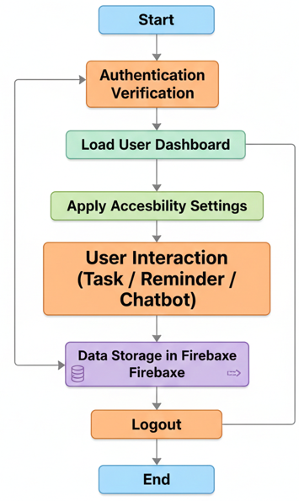
This structured flow ensures that users always know their current position in the system and what action comes next, promoting confidence and ease of use.

9.4 Database Diagram (Conceptual Explanation)
The PRIHUB database is designed using a normalized and scalable architecture to support real-time access, secure data storage, and efficient retrieval.
Main Tables / Collections
- User – Stores user profile details and role information
- Caregiver – Maintains caregiver profiles and linked users
- Task – Stores task descriptions, deadlines, and completion status
- Reminder – Manages scheduled alerts and notifications
- Chatbot Logs – Records chatbot interactions for system improvement
- Settings – Stores accessibility preferences for each user
Key Relationships
- One User → Many Tasks
- One User → Many Reminders
- One User → Many Chatbot Interactions
- One Caregiver → Many Users
This database structure ensures:
- Data integrity through defined relationships
- Minimal redundancy by avoiding duplicate records
- Fast data retrieval using Firebase’s real-time capabilities
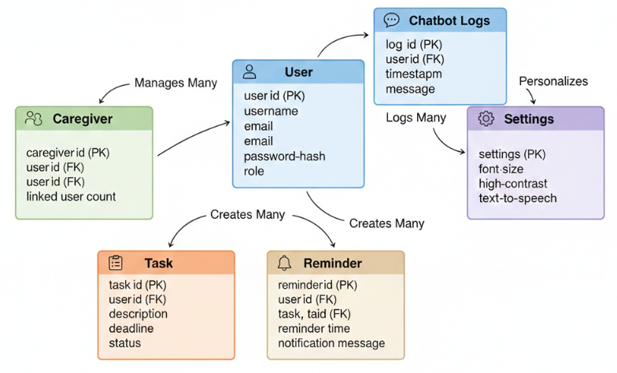
CHAPTER – 10.
INPUT & OUTPUT SCREEN DESIGN
10. Input and Output Screen Design
The PRIHUB system’s input and output screens are designed using accessibility-first and user-centred design principles. Special consideration is given to users with cognitive and visual disabilities to ensure ease of use, clarity, and reduced mental effort. Every screen follows consistent design patterns to help users navigate the system confidently.
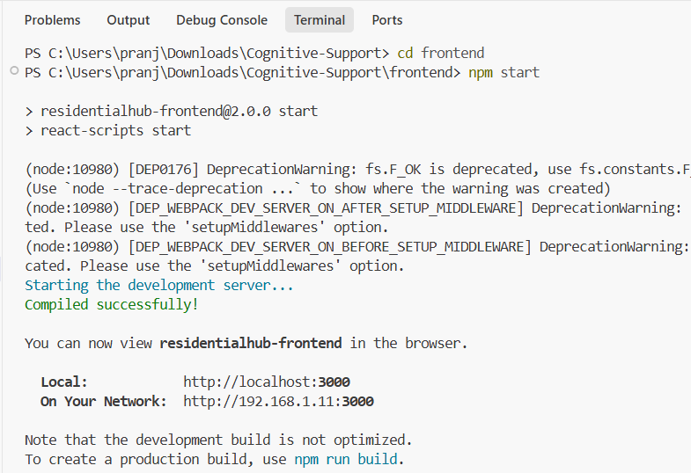
10.1 Input Screen Design
Input screens in PRIHUB are structured to allow users to provide information with minimal complexity. The design focuses on simplicity, clarity, and multiple accessibility support options to accommodate different user needs.
Key Input Screens
- Login & Registration Screen
This screen allows users to securely access the system. It includes:
- Simple form fields for email and password
- Clearly labelled input fields with icons
- Large, easy-to-identify login and register buttons
- Error messages displayed in both text and audio formats
The screen supports screen readers and keyboard navigation to ensure inclusive access.

- Accessibility Preference Setup Screen
This screen enables users or caregivers to personalize accessibility settings, such as:
- Font size adjustment sliders
- Color contrast selection options
- Text-to-Speech enable/disable toggle
- Keyboard navigation activation
These settings are saved automatically and applied during every login.

- Task Creation Screen
The task creation screen allows users to add and manage daily tasks. Features include:
- Minimal text fields with clear instructions
- Dropdown menus instead of free text wherever possible
- Large action buttons (Add, Save, Cancel)
- Optional voice input support for ease of use

- Reminder Scheduling Screen
This screen helps users schedule reminders efficiently. It includes:
- Simple date and time selectors
- Clear labels and confirmation prompts
- Audio alerts preview option
- Easy modification and deletion options

- Chatbot Interaction Screen
The chatbot input screen allows users to interact using natural language. It supports:
- Text input and optional voice input
- Simple chat interface with minimal distractions
- Real-time feedback while typing or speaking

Design Features of Input Screens
- Large buttons and readable fonts to reduce visual strain
- High-contrast themes for improved visibility
- Keyboard-only navigation for users with limited motor control
- Screen reader compatibility for visually impaired users
- Minimal text input fields to reduce cognitive load

10.2 Output Screen Design
Output screens in PRIHUB focus on presenting information clearly and understandably. The goal is to ensure users can easily interpret system responses, confirmations, and alerts without confusion.
Key Output Screens
- User Dashboard
The dashboard serves as the central control panel and displays:
- Task summaries
- Upcoming reminders
- Quick access to chatbot assistance
The layout is clean, uncluttered, and logically organized.

- Task List View
This screen displays all user tasks in a structured manner, including:
- Task names
- Due dates
- Completion status indicators
Visual icons and colour cues help users quickly understand task status.

- Reminder Notifications
Reminder outputs are delivered through:
- On-screen alerts
- Audio notifications
- Clear reminder descriptions
These notifications ensure users do not miss important activities.

- Chatbot Response Window
The chatbot output screen displays responses in:
- Simple, easy-to-understand language
- Step-by-step instructions where necessary
- Both text and optional audio output

Output Characteristics
- Visual and audio feedback to confirm user actions
- Clear success and error messages using simple language
- Simplified layouts to avoid overwhelming users
- Consistent UI patterns across all screens for familiarity and ease of learning
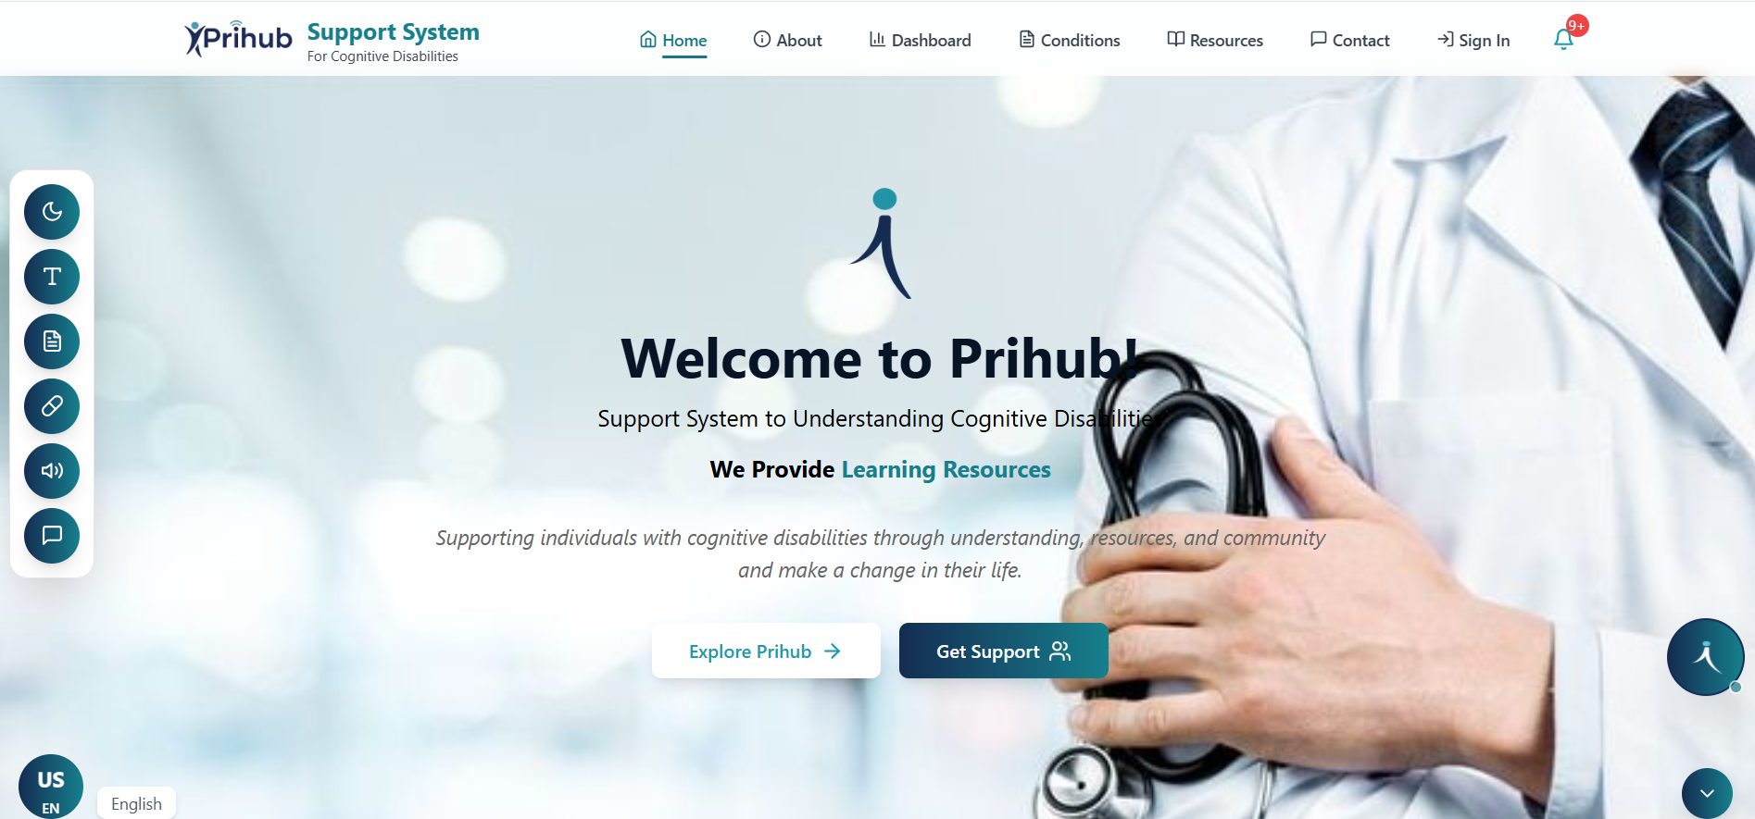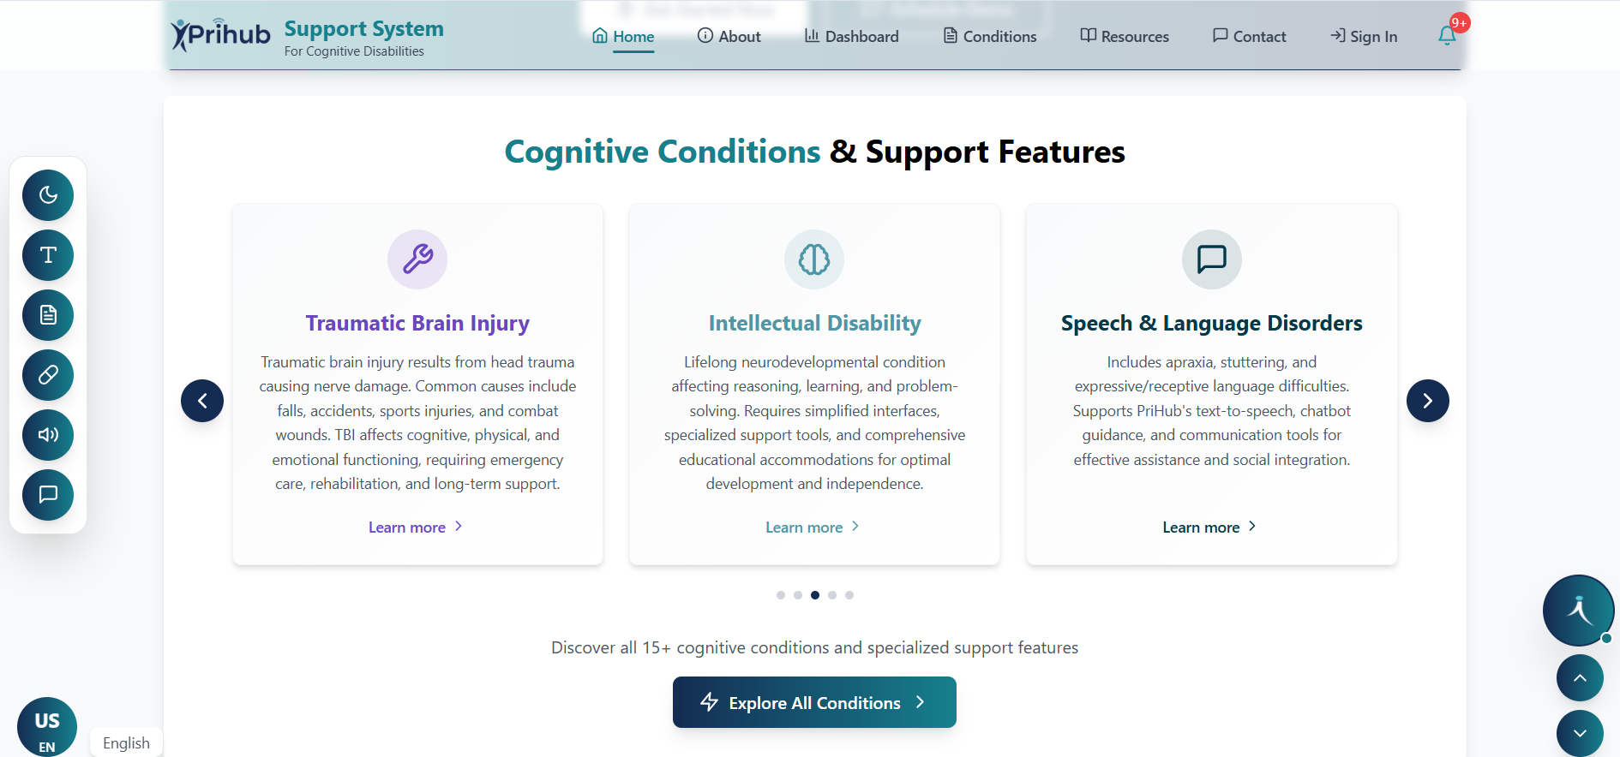
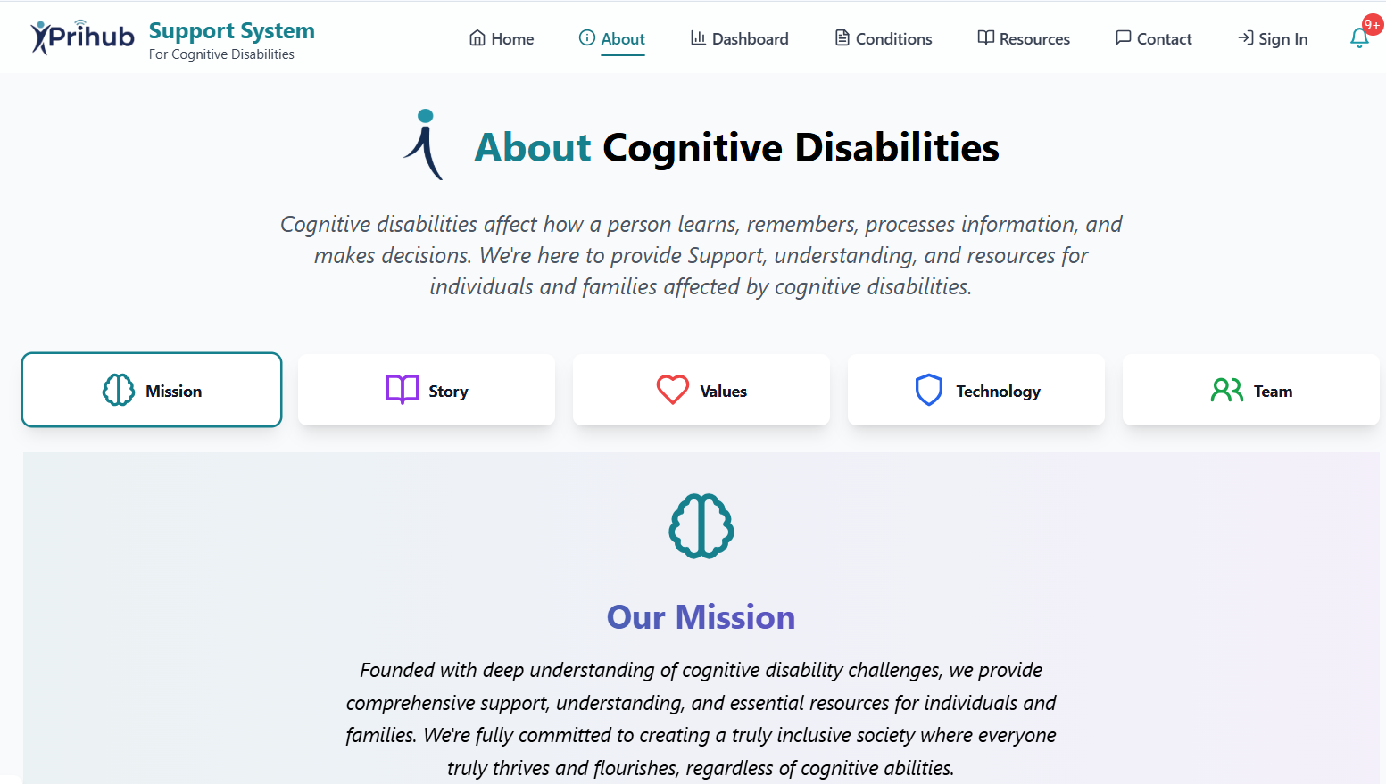
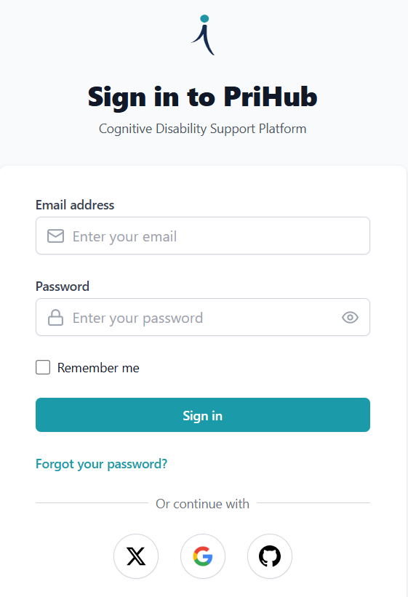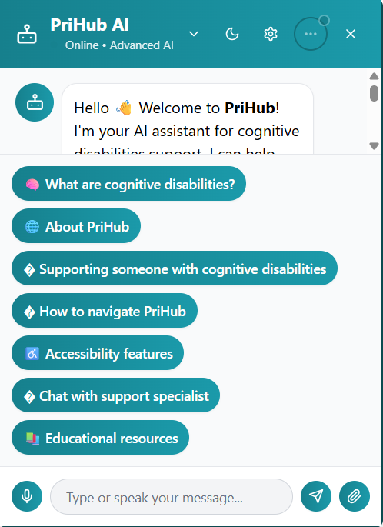
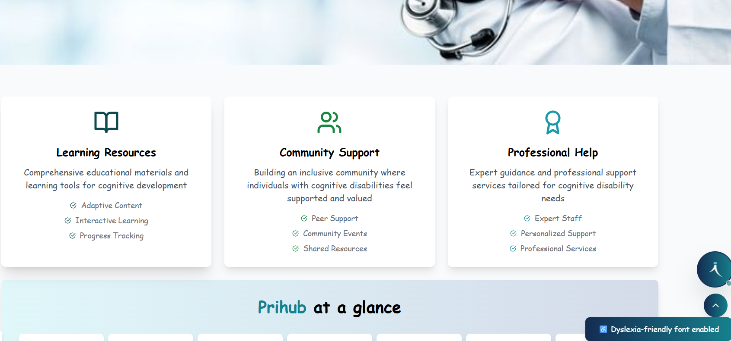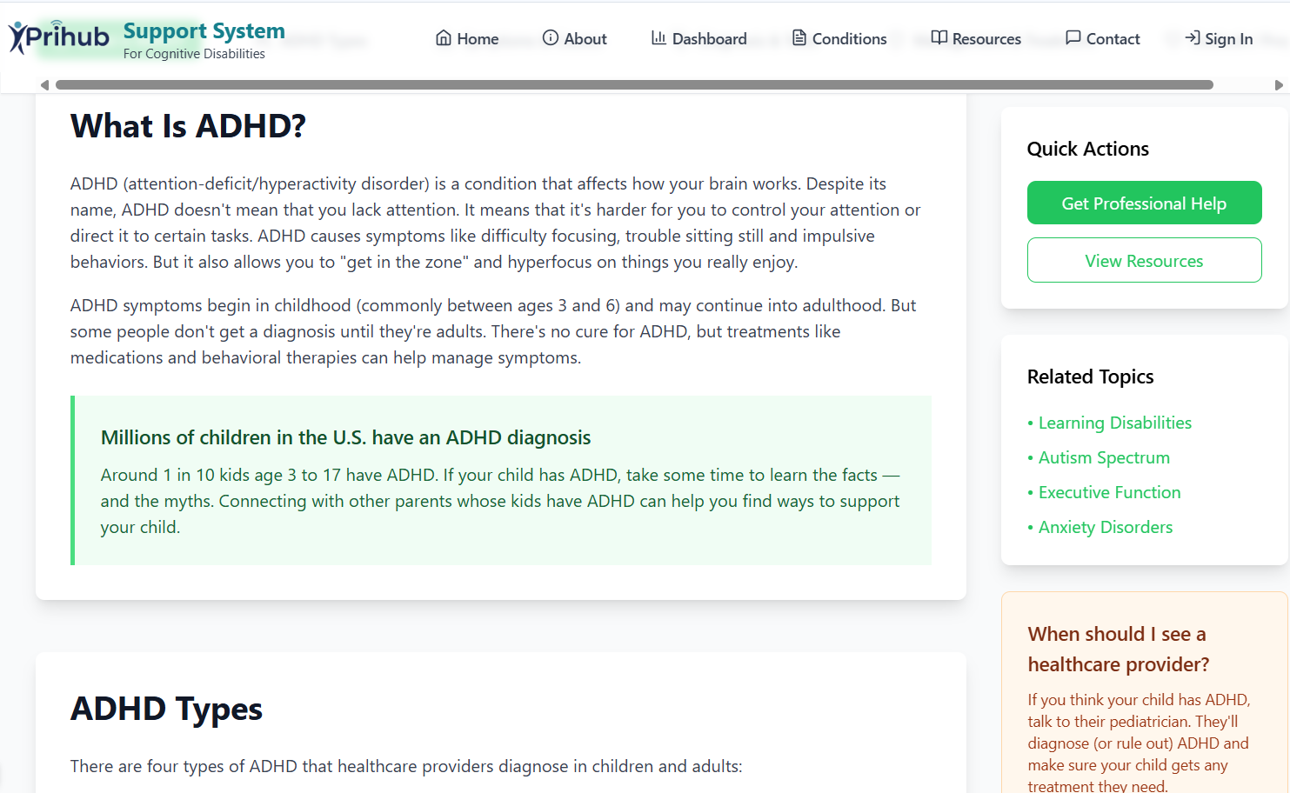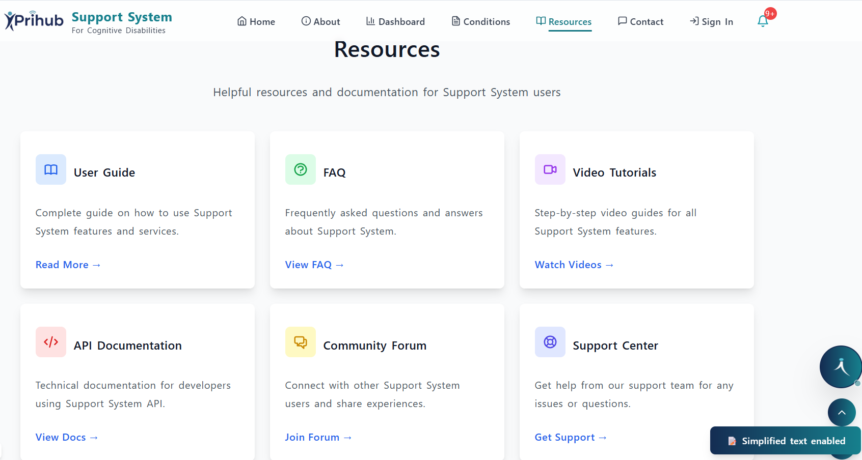
CHAPTER – 11.
PRINTOUT OF THE CODE SHEET (CODING)
The PRIHUB system is implemented using a modular, scalable, and maintainable coding approach. The development follows industry best practices to ensure reliability, readability, accessibility, and ease of future enhancements. The source code is structured clearly and divided into frontend and backend components.

11.1 Frontend Implementation
The frontend of PRIHUB is developed using React.js, which enables the creation of a responsive and component-based user interface.

Key Frontend Features
- React.js Components The user interface is divided into reusable components such as Login, Dashboard, Task Manager, Reminder Module, and Chatbot Interface. This modular design improves code reusability and simplifies maintenance.
- Reusable UI Elements Common elements like buttons, input fields, alerts, and navigation menus are reused across multiple screens to maintain consistency and reduce redundancy.

- Accessibility-Focused Design: The frontend uses:
- ARIA roles to enhance screen reader compatibility
- Semantic HTML elements to improve structure and accessibility
- Keyboard navigation support for all interactive components
These practices ensure compliance with accessibility standards and enhance usability for users with disabilities. 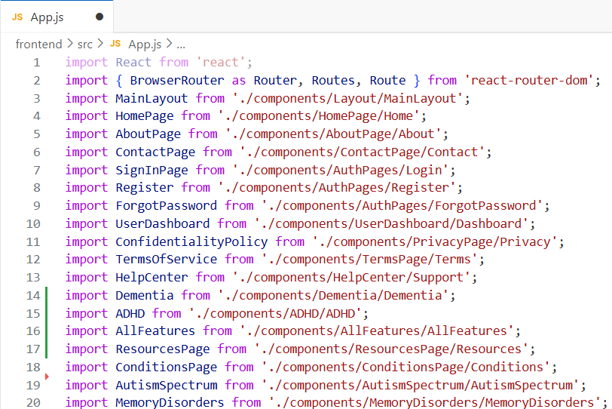
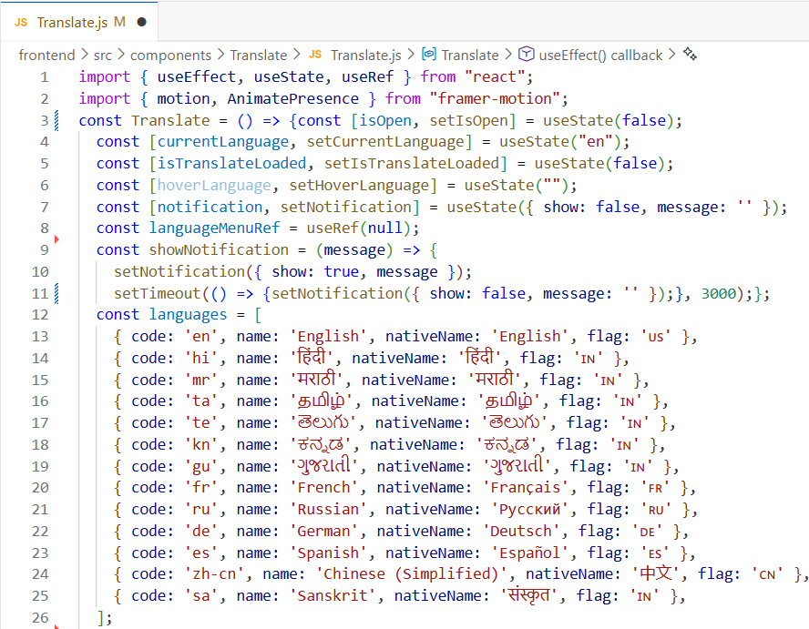
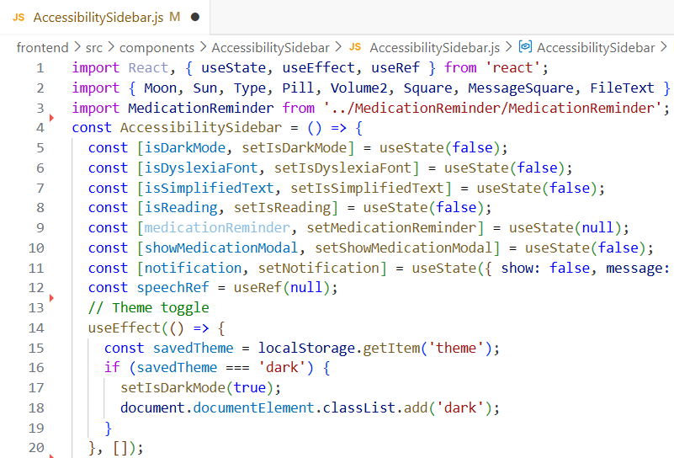
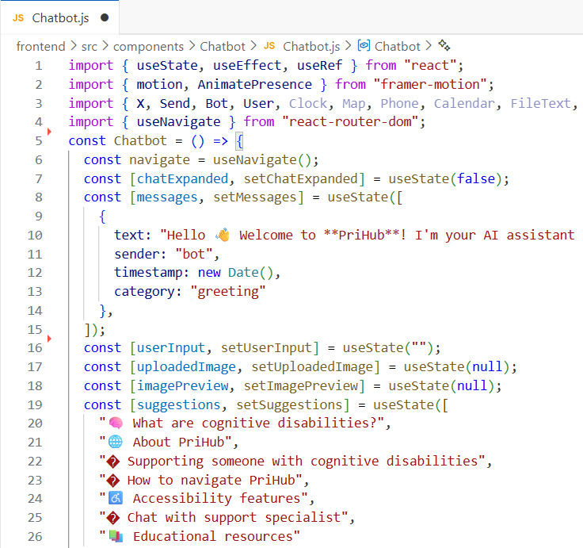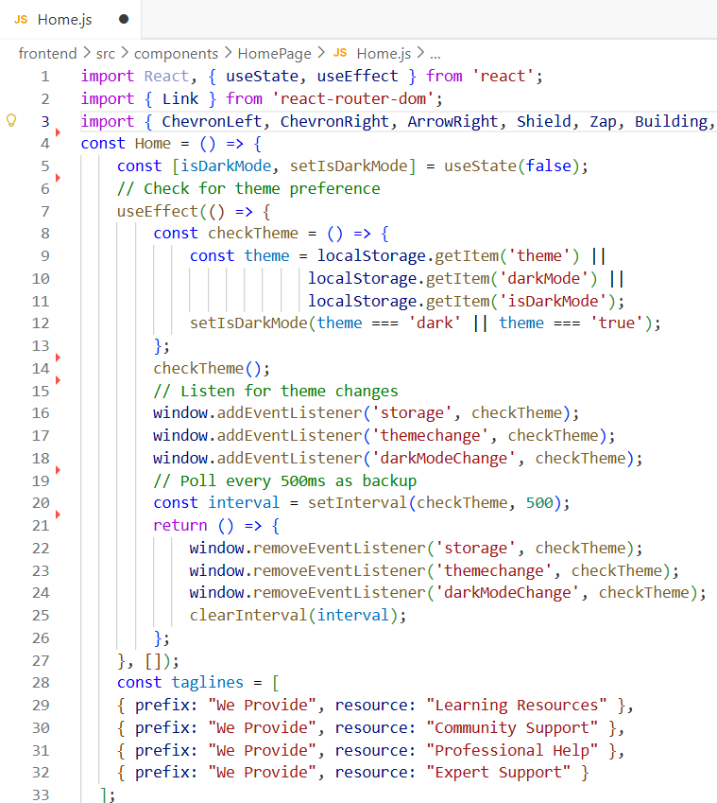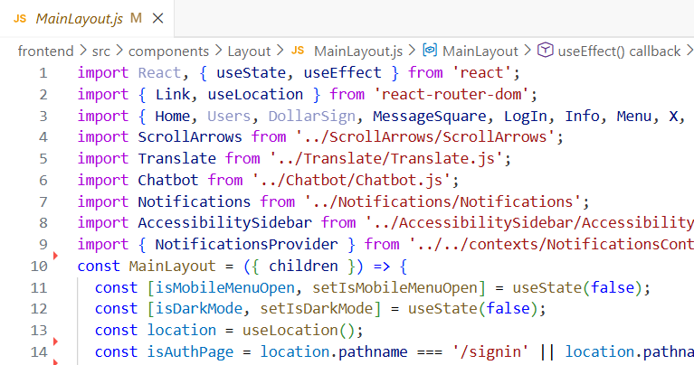
11.2 Backend Implementation
The backend of PRIHUB is developed using Node.js and Express.js, providing a robust and efficient server-side environment.
Key Backend Features
- Node.js & Express.js APIs: RESTful APIs are used to handle requests related to user authentication, task management, reminders, and chatbot interactions.
- Firebase Authentication Handling: Firebase Authentication is integrated to securely manage user login, registration, and role-based access control.
- Secure Database Operations: All data interactions with the Firebase Database are protected using authentication rules and secure API endpoints, ensuring data privacy and integrity.
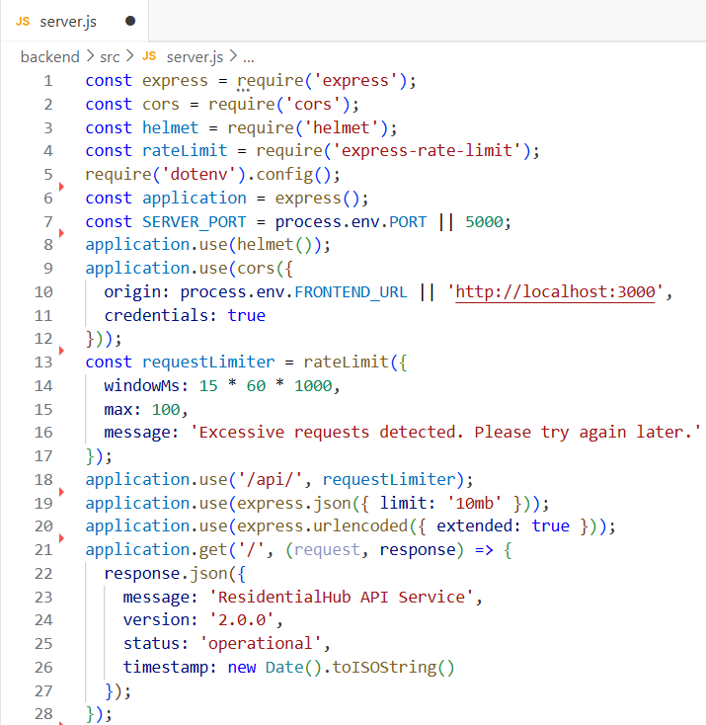
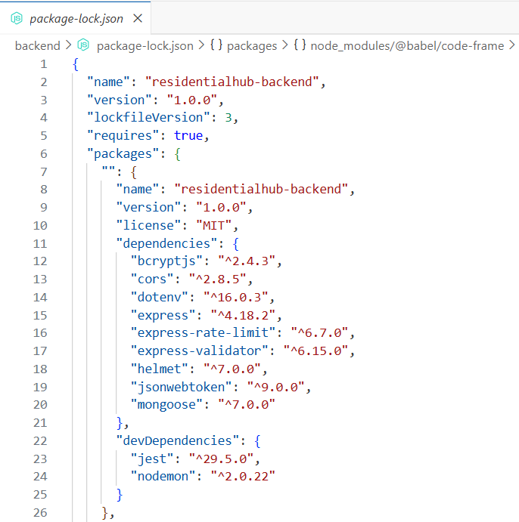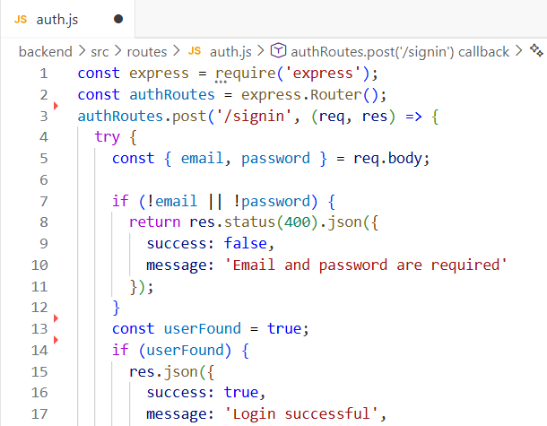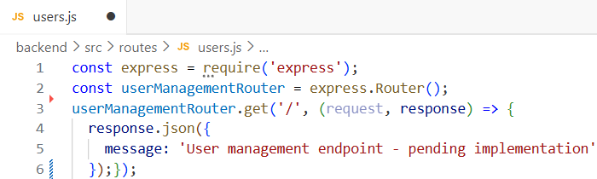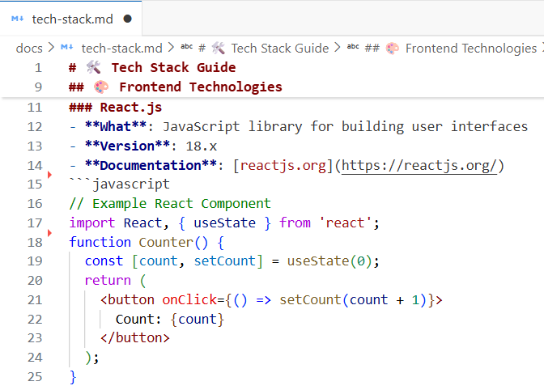11.3 Code Quality Practices
To maintain high-quality and maintainable code, the following practices are consistently applied throughout the project:
- Meaningful Variable Naming: Variables, functions, and components are named clearly to reflect their purpose, improving code readability.
- Component-Based Architecture: The system follows a component-based structure, allowing independent development, testing, and reuse of modules.
- Commented Code for Clarity: Important sections of the code are properly commented to explain logic, making it easier for future developers to understand and modify the system.
CHAPTER - 12.
TESTING
Testing is a crucial phase in the PRIHUB project to ensure reliability, security, accessibility, and usability. Since PRIHUB serves users with cognitive and visual disabilities, any failure can impact user trust and independence. Therefore, a structured SDLC-based testing approach was adopted, integrating technical validation and user-focused evaluation to meet functional, non-functional, and accessibility requirements.

12.1 Types of Testing
1. Unit Testing
Unit testing validated individual modules in isolation to ensure correct functionality. Tested components included:
- User authentication and registration validation
- Task creation, update, and deletion
- Reminder scheduling and notifications
- Accessibility preference settings (font, contrast, themes)
- Chatbot query handling
Purpose: Detect early errors, simplify debugging, and ensure stable module performance.
Outcome: All modules functioned as expected, providing a reliable foundation for integration.

2. Integration Testing
Integration testing verified seamless interaction between system modules. Key areas tested:
- Frontend React components with backend APIs
- Firebase Authentication and role-based access
- Task and reminder synchronization with Firebase Database
- AI chatbot interaction with user context
Purpose: Ensure consistent data flow, module compatibility, and real-time synchronization.
Outcome: All modules integrated smoothly with accurate data handling.

3. System Testing
System testing evaluated PRIHUB as a complete platform. Scenarios included:
- End-to-end workflows: login → dashboard → task/reminder management → chatbot navigation → logout
- Application of accessibility settings across pages
- Performance, reliability, and cross-browser/device compatibility
Purpose: Validate end-to-end functionality, system stability, and real-world readiness.
Outcome: PRIHUB met all functional and non-functional requirements and operated reliably.

4. Accessibility Testing (WCAG 2.1)
Accessibility testing ensured compliance with WCAG 2.1 principles (Perceivable, Operable, Understandable, Robust). Key checks:
- Screen reader compatibility using semantic HTML and ARIA roles
- Keyboard-only navigation
- Adequate colour contrast and readable fonts
- Simplified layouts and predictable navigation
Purpose: Guarantee inclusive, barrier-free interaction and reduced cognitive load.
Outcome: PRIHUB achieved full accessibility compliance for users with disabilities.

5. Security Testing
Security testing verified protection of sensitive user data and system integrity, covering:
- Authentication, authorization, and role-based access
- Secure session handling
- Input validation and prevention of unauthorized access
Purpose: Detect vulnerabilities and ensure confidentiality, integrity, and availability.
Outcome: No critical vulnerabilities were found; system demonstrated strong security.

6. User Acceptance Testing (UAT)
UAT assessed usability and user satisfaction with real users and caregivers. Focus areas:
- Ease of navigation and task execution
- Effectiveness of AI chatbot guidance
- Comfort and personalization of accessibility settings
- Confidence and independence in using the platform
Outcome: Users reported high satisfaction, confirming PRIHUB’s intuitiveness, accessibility, and effectiveness.

12.2 Summary of Testing Results
Testing Type | Result
Unit Testing | Passed
Integration Testing | Passed
System Testing | Passed
Accessibility Testing | WCAG 2.1 Compliant
Security Testing | Secure
User Acceptance Testing | Approved

Conclusion:
The testing phase confirmed that PRIHUB is a reliable, secure, accessible, and user-friendly platform, ready for deployment and long-term use in inclusive digital environments.

CHAPTER - 13.
USER / OPERATIONAL MANUAL
The User / Operational Manual provides comprehensive guidance for all types of users, including individuals with disabilities, caregivers, and system administrators. Its purpose is to ensure safe, efficient, and confident use of the PRIHUB platform.

13.1 User Guide
The PRIHUB user guide is designed with step-by-step instructions to assist users in navigating the system. Key instructions include:
- Login and Registration Process: Users can securely register with a valid email and password, and log in using Firebase Authentication. Role-based access ensures users only see features relevant to them.
- Using the AI Chatbot for Assistance: The chatbot provides real-time guidance and answers queries. Users can type or speak their requests. The chatbot simplifies navigation and reduces cognitive load by giving stepwise instructions.
- Creating, Updating, and Managing Tasks and Reminders: Users can easily add tasks with deadlines, mark tasks as complete, or delete them. Reminders can be scheduled, modified, or cancelled. All changes are reflected in real-time to keep the system updated.
- Customizing Accessibility Settings: Users can personalize settings to suit their visual or cognitive needs:
  - Adjustable font size
  - High-contrast themes
  - Text-to-Speech for audio feedback
  - Keyboard navigation for hands-free interaction
This ensures a consistent and inclusive user experience.

13.2 Security Aspects
PRIHUB emphasizes data protection and secure usage. Key security features include:
- Secure Authentication Using Firebase: User credentials are securely stored and verified through Firebase Authentication, preventing unauthorized access.
- Encrypted Data Transmission: All communication between frontend and backend is encrypted, safeguarding sensitive user data such as tasks, reminders, and personal settings.
- Role-Based Access Control: Each user role (User, Caregiver, Admin) has access only to the functions and data necessary for their responsibilities. This limits exposure of sensitive information.
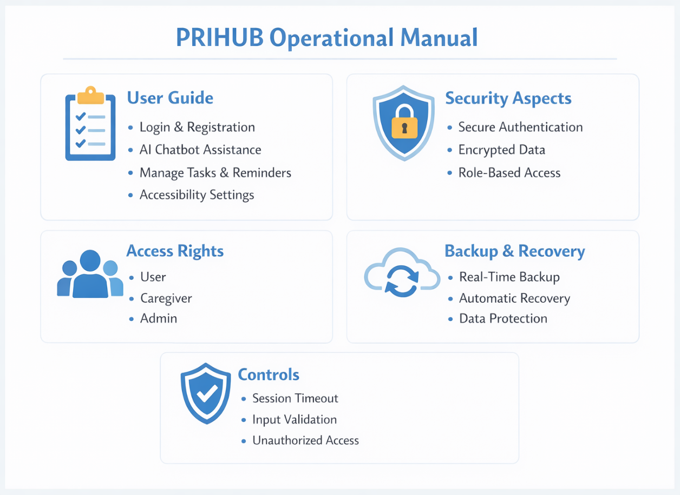
13.3 Access Rights
Clear access rights ensure proper usage and monitoring:
- User: Can manage personal tasks, reminders, and accessibility preferences. Limited to their own data for privacy and simplicity.
- Caregiver: Can monitor and assist multiple users assigned to them. They help with task completion and accessibility setup.
- Admin: Has full system management rights, including user management, system configuration, and monitoring logs for security and performance purposes.

13.4 Backup and Recovery
To prevent data loss and ensure continuity, PRIHUB includes robust backup and recovery mechanisms:
- Cloud-Based Real-Time Backups: All user data is synchronized in real-time to Firebase, ensuring changes are instantly saved and recoverable.
- Automatic Recovery Mechanisms: In case of system errors or network failures, data is automatically restored from the latest backup.
- Minimal Risk of Data Loss: The combination of cloud storage, real-time synchronization, and secure authentication reduces potential data loss to near zero.

13.5 Controls
Operational controls are built into the system to prevent misuse and maintain data integrity:
- Session Timeout: Inactive sessions are automatically logged out to prevent unauthorized access.
- Input Validation: All user inputs are checked for correctness, format, and potential malicious content, preventing errors and security threats.
- Unauthorized Access Prevention: Only verified users can access the system, and roles are strictly enforced to limit data exposure.

CHAPTER - 14.
CONCLUSIONS
The PRIHUB project delivers an inclusive, accessibility-first digital platform for individuals with cognitive and visual disabilities. It’s primary objective is to reduce digital barriers and enable users to interact with technology confidently and independently by emphasizing accessibility, usability, and intelligent assistance. This approach creates a supportive environment that addresses diverse user needs. Key achievements include:
- Enhanced Digital Independence: PRIHUB helps users manage activities, set reminders, access information, and communicate independently. Simplified interfaces and guided workflows reduce reliance on caregivers while improving self-confidence and autonomy.
- Accessibility Compliance: The platform follows WCAG 2.1 standards and offers high-contrast modes, adjustable text sizes, text-to-speech, keyboard navigation, and screen reader support. Clear layouts and consistent navigation enhance usability for users with visual and cognitive limitations.
- AI-Driven Assistance: PRIHUB includes an intelligent chatbot that provides real-time guidance, answers queries, and simplifies complex tasks. This structured support minimizes cognitive overload and improves user engagement.
- Structured Development: The project follows SDLC best practices to ensure reliability, security, and scalability. Regular updates, secure data handling, and modular design support long-term stability and future growth.
- User-Centred Improvement: Continuous feedback, usability testing, and accessibility evaluations help improve system functionality and interface clarity, ensuring alignment with user needs.
Overall, the project demonstrates how technology can bridge accessibility gaps, promote social inclusion, and empower users to confidently interact with digital systems.
CHAPTER - 15.
FUTURE ENHANCEMENTS
To further improve the system’s functionality, accessibility, and user experience, several future enhancements are proposed for the PRIHUB platform. These enhancements aim to extend the system’s reach, improve usability, and incorporate advanced technologies to better serve individuals with cognitive and visual disabilities. following enhancements are proposed:
- Mobile Applications (Android/iOS): Developing mobile apps will enable users to access PRIHUB anytime and anywhere. Features such as push notifications and offline access will improve convenience and engagement.
- Multilingual Support: Supporting multiple languages will increase accessibility for users from different regions, helping them interact with the system in their preferred language.
- AI-Based Behaviour Prediction: AI and predictive analytics can analyze user patterns and proactively suggest reminders and tasks, improving personalization and activity management.
- Integration with Government and Public Services: Linking PRIHUB with official portals can simplify access to healthcare, welfare, and documentation services, enhancing user independence.
- Support for Wearable Devices: Integration with smartwatches and fitness bands will provide real-time alerts and reminders, ensuring continuous on-the-go assistance.
- Voice-Only Navigation Mode: Voice-based operation will allow hands-free interaction, benefiting visually impaired users and those with limited motor abilities.
Overall, These enhancements will strengthen PRIHUB as an intelligent accessibility platform. By integrating mobile access, multilingual support, AI, public services, wearables, and voice control, the system will offer a more inclusive, personalized, and efficient digital experience, improving users’ quality of life.
CHAPTER - 16.
LIST OF PUBLICATIONS WITH CERTIFICATES

CHAPTER - 17.
REFERENCES
[1] Singh, A., Verma, R., Patel, S., “Artificial Intelligence-Based Assistive Technologies for Cognitive Disabilities”, IEEE Access, USA, ISSN: 2169-3536, Vol. 13, PP. 11245–11260, 2025.
[2] Ferreira, M., Carneiro, P., Costa, V. M., Carvalho, F., Meisel, A., Capela, J. P., “Amphetamine and Methylphenidate Potential on the Recovery from Stroke and Traumatic Brain Injury: A Review”, Reviews in the Neurosciences, Germany, ISSN: 2191-0200, Vol. 35, PP. 709–746, 2024.
[3] Khachadourian, V., Mahjani, B., Sandin, S., Kolevzon, A., Buxbaum, J. D., Reichenberg, A., Janecka, M., “Comorbidities in Autism Spectrum Disorder and Their Etiologies”, Translational Psychiatry, UK, ISSN: 2158-3188, Vol. 13, PP. 1–7, 2023.
[4] Kian, N., Samieefar, N., Rezaei, N., “Prenatal Risk Factors and Genetic Causes of ADHD in Children”, World Journal of Pediatrics, USA, ISSN: 1708-8569, Vol. 18, PP. 308–319, 2022.
[5] Brignell, A., Harwood, R. C., May, T., Woolfenden, S., Montgomery, A., Iorio, A., Williams, K., “Overall Prognosis of Preschool Autism Spectrum Disorder Diagnoses”, Cochrane Database of Systematic Reviews, UK, ISSN: 1465-1858, Vol. 9, PP. CD012749, 2022.
[6] Verma, S., Gupta, N., “Mobile-Based Rehabilitation Systems for Cognitive Disorders”, Journal of Medical Systems, USA, ISSN: 0148-5598, Vol. 45, PP. 87–98, 2021.
[7] World Health Organization (WHO), “Assistive Technology and Disability Support”, PubMed Central, USA, ISSN: 1474-8608, Vol. 12, PP. 145–158, 2019.
[8] Gałecki, P., Talarowska, M., Anderson, G., et al., “Mechanisms Underlying Neurocognitive Dysfunctions in Recurrent Major Depression”, Medical Science Monitor, USA, ISSN: 1643-3750, Vol. 21, PP. 1535–1547, 2015.
[9] American Psychological Association Task Force, “Cognitive Rehabilitation Systems”, PubMed Central, USA, ISSN: 0033-2909, Vol. 140, PP. 102–118, 2014.

